 | Year 11 Methods  Term 2 Week 4 Quiz | $$\frac{}{22}$$

Name: __________________
1. | Shade the region of the Venn Diagram indicated by the following sets.  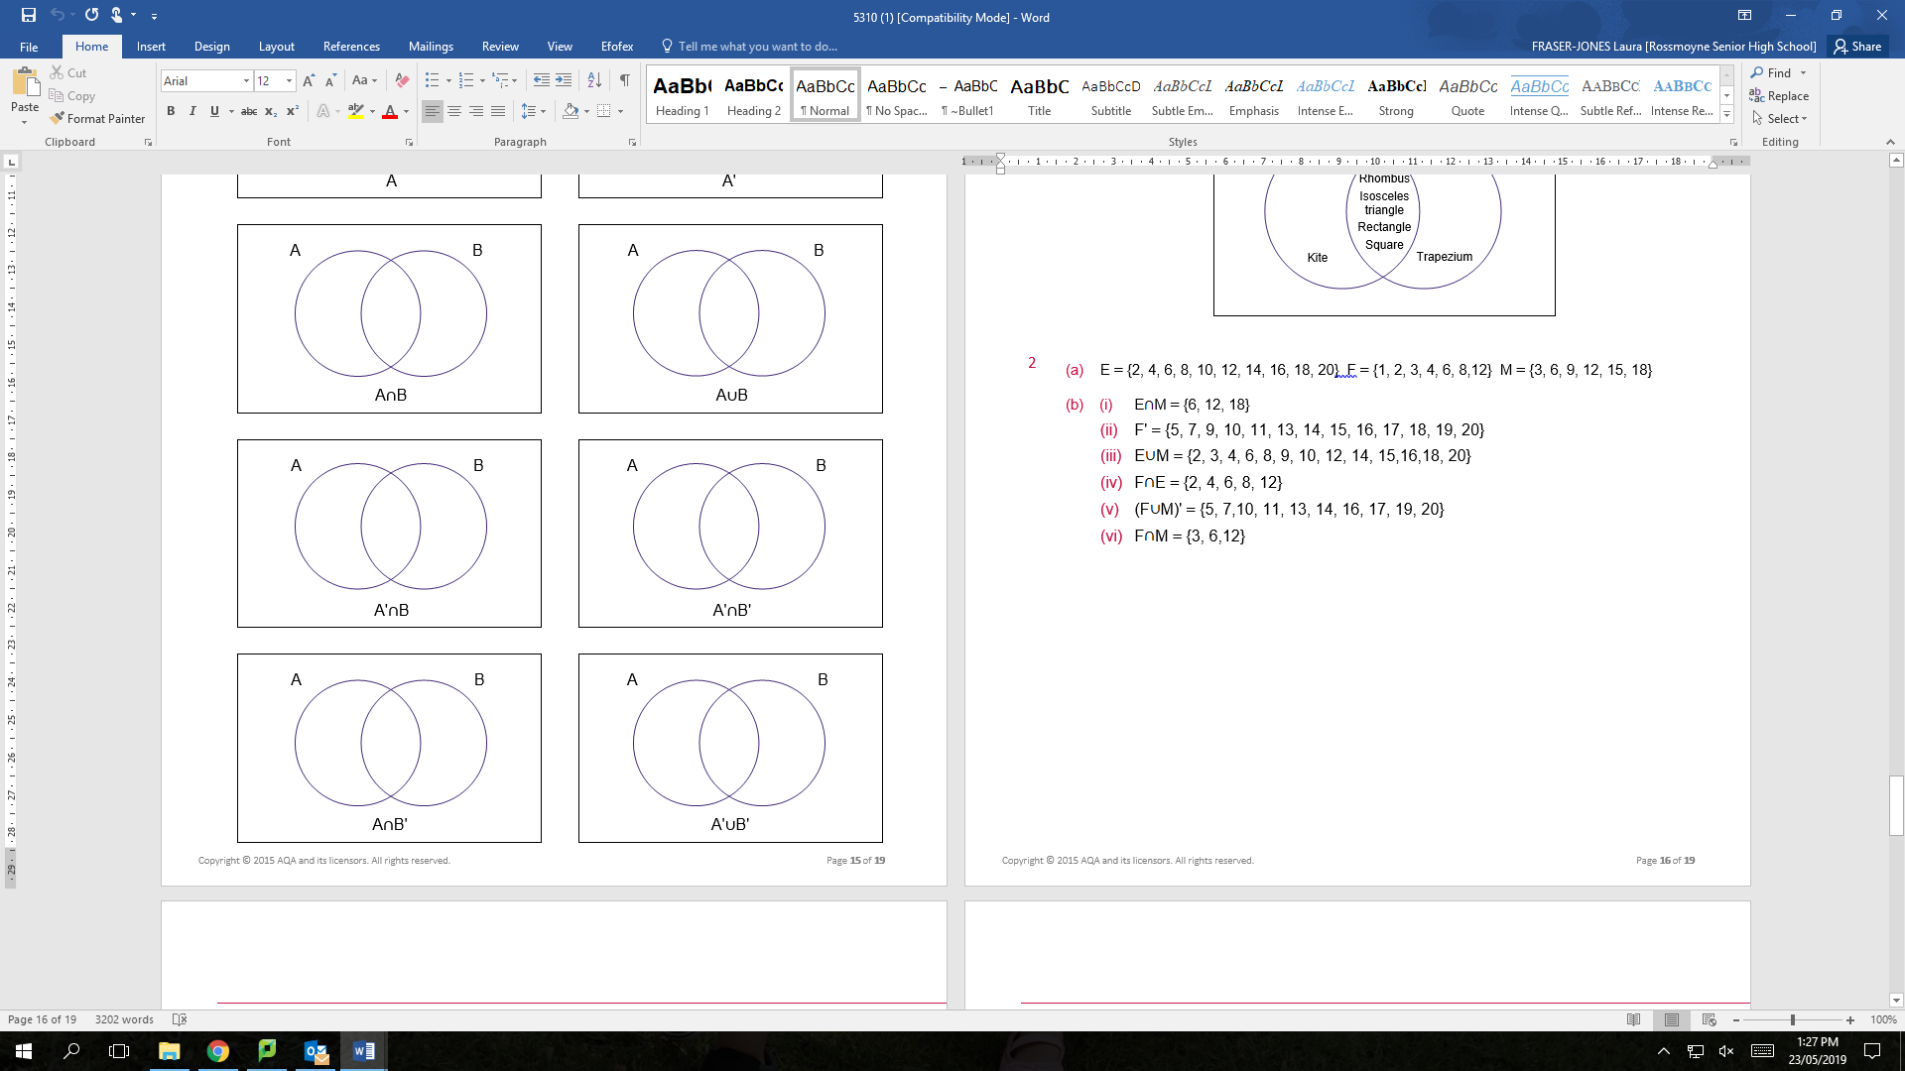    (A B)’ C | 4
2. | What is the part of a Venn Diagram where two circles overlap is called and what is the symbol?  A  B  C | 2
3. | Find if n(A) = 10, n(B) = 8, = 4 | 2
4. | Let set A be defined as A = { x : x is a positive integer less than 10 } .  - State n( A)  - Explain whether the statement 0 ∈ A is true or false. | 2
5. | Find the exact value of:  (a) (b) $\cos{\frac{5π}{6}}$ (c) | 3
6. | Let set B ={ 1, 2, 3, 4 }. An integer is formed by choosing two digits, at random and without repetition, from B .  - Illustrate this in a tree diagram  - Determine the probability that the integer formed is a prime number.  - Determine the probability that the integer formed is even, given that it is a multiple of three. | 5
7. | The universal set is the set of integers from 1 to 20, A is the set of numbers divisible by 3, B is the set of square numbers and C is the set of prime numbers.  - Describe the set A ∩B∩C  - Determine A∪ B  - Determine n(A∪B∪C)’  - A number is selected at random from the universal set, determine P(A|B) | 4

